ASSIGNMENT NUMBER 5
STATEMENT:-Create user defined exception to check the following condition and throw the exception if the criteria does not meet.
a) Users stays in Pune/Mumbai/Bangalore/Chennai
b) User has 4-wheeler
City , vehicle from the user and check for the conditions mentioned above. If any of the
condition not met then throw the exception. If user does not enter proper input throw the
exception.
AIM:
C++ program to implement and understand the concept of exception handling. To
understand the concept like throw , catch , try , etc. of the exception handling. Using this,
check the conditions given in above problem.
DESCRIPTION:
The one advantage of C++ over C is the Exception handling . This program explains how
EXCEPTION are handled in C++. The code that is likely to throw exceptions is enclosed in
the “try” block. The try block can also contain a “throw” statement that is used to explicitly
throw exceptions. The “throw” statement consists of a keyword “throw” followed by a
parameter which is the exception name. This parameter is then passed to the catch block.
The exception thrown in the “try” block is passed on to the “catch” block. The catch block
contains the code to process the thrown exception. It can contain merely a message or
an entire code block to process the exception such that the normal flow of the program
is not hindered.
It is not necessary that each try block should be followed by only one catch block. If our
try block code contains the statements that can throw more than one exceptions, then
we can have multiple catch blocks wherein each catch block provides processing for
each of the exceptions.

OOP CONCEPT USED:
a) Exception handling
b) Menu driven program
c) Use of while loop
SOURCE CODE:
#include<iostream> //standard input output header file
#include<stdexcept> //for handling exception
#include<typeinfo> //for variable datatype identification
#include<string> //string comparison purpose
#include<cstring> //for string manipulation in c/c++ for various fun. and array

using namespace std;

int main()
{
int i,n;
char car;
char city[20];
cout<<"\n ENTER THE CITY OF PERSON:";
cin>>city;
try
{
if(strcmp(city, "Pune")&& strcmp(city, "Banglore")&& strcmp(city,"Chennai")&& strcmp(city, "Mumbai"))
throw runtime_error("\n PERSON IS NOT STAYING IN Pune/Mumbai/Banglore/Chennai");
}
catch(const exception& e)
{
cout<<"CAUGHT EXCEPTION:"<<e.what()<<'\n';
}

cout<<"\n WHETHER THE PERSON HOLDS 4 WHEELER OR NOT? (y/n):";
cin>>car;
try
{
if(car=='n')
throw runtime_error("\n PERSON SHOULD HOLD FOUR WHEELER");
}
catch(const exception& e)
{
cout<<"CAUGHT EXCEPTION:"<<e.what()<<'\n';
}

cout<<"\n INFORMATION OF THE PERSON IS AS FOLLOWS:";
cout<<"\n LOCATION:"<<city;
cout<<"\n HOLDING 4 WHEELER OR NOT?:"<<car<<endl;

return 0;
}
OUTPUT:

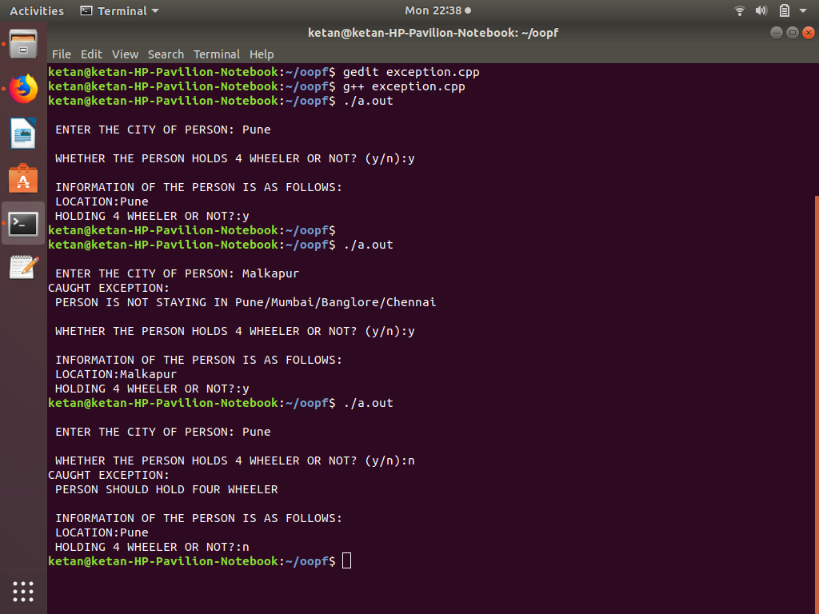

CONCLUSION: –
So in this program we learn the concept of Exception handling and its working . Also get to
know when and how to use it .

